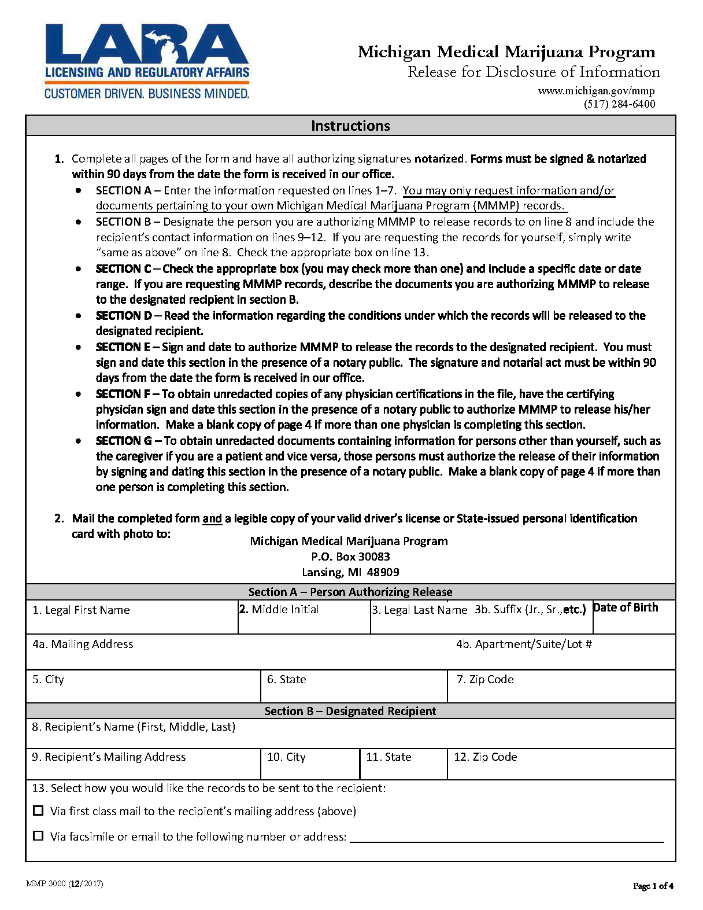
Batman
01/01/1979
Secret Location Under Office Building
Gotham
NJ

Axiom Requisition Copy Service
2869 Jolly Road,
Okemos
MI
48864
X
X
(517) 886-4116
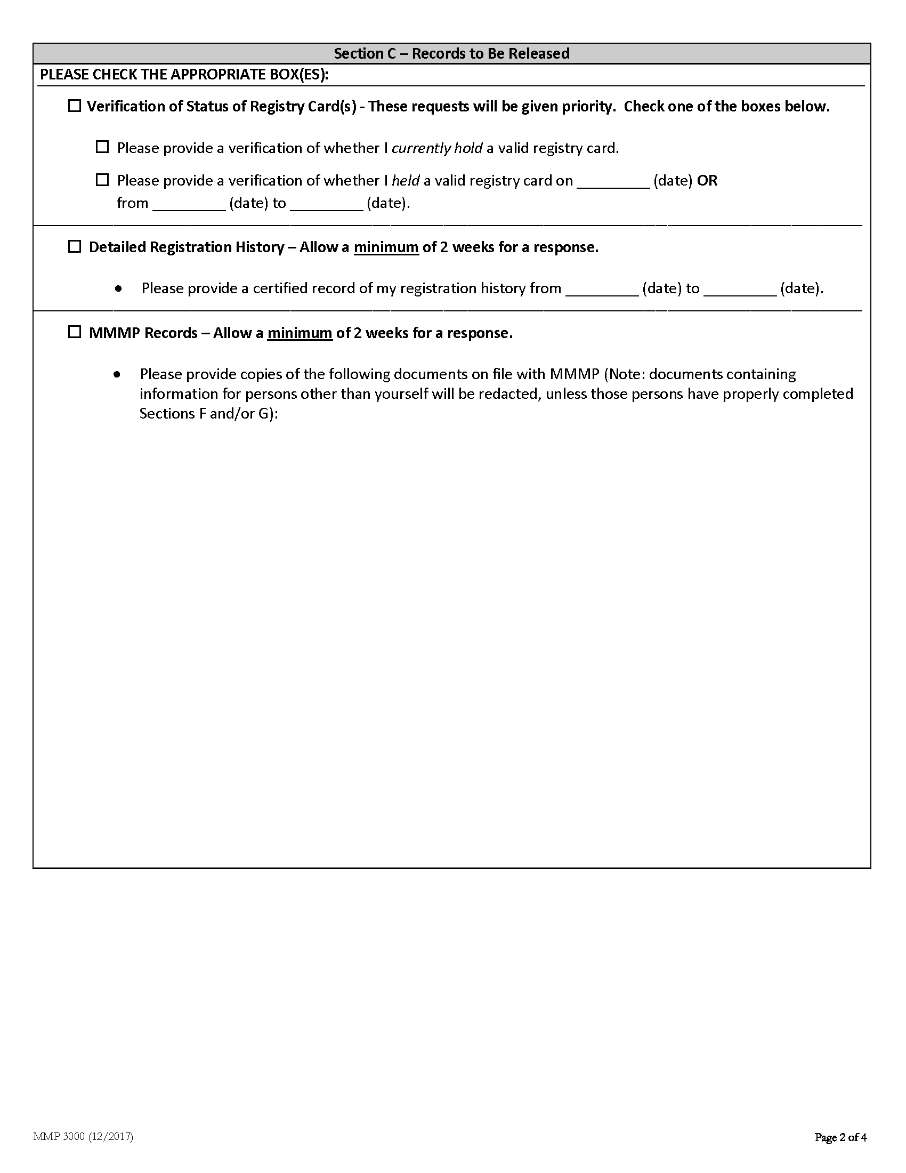
01/01/1979
PRESENT
X
X
FROM 01/01/1979 TO PRESENT: Any and all MEDICAL RECORDS, including but not limited to patient history form(s), reports, etc. pertaining to Batman SSN: xxx-xx-5555, DOB: 01/01/1979.
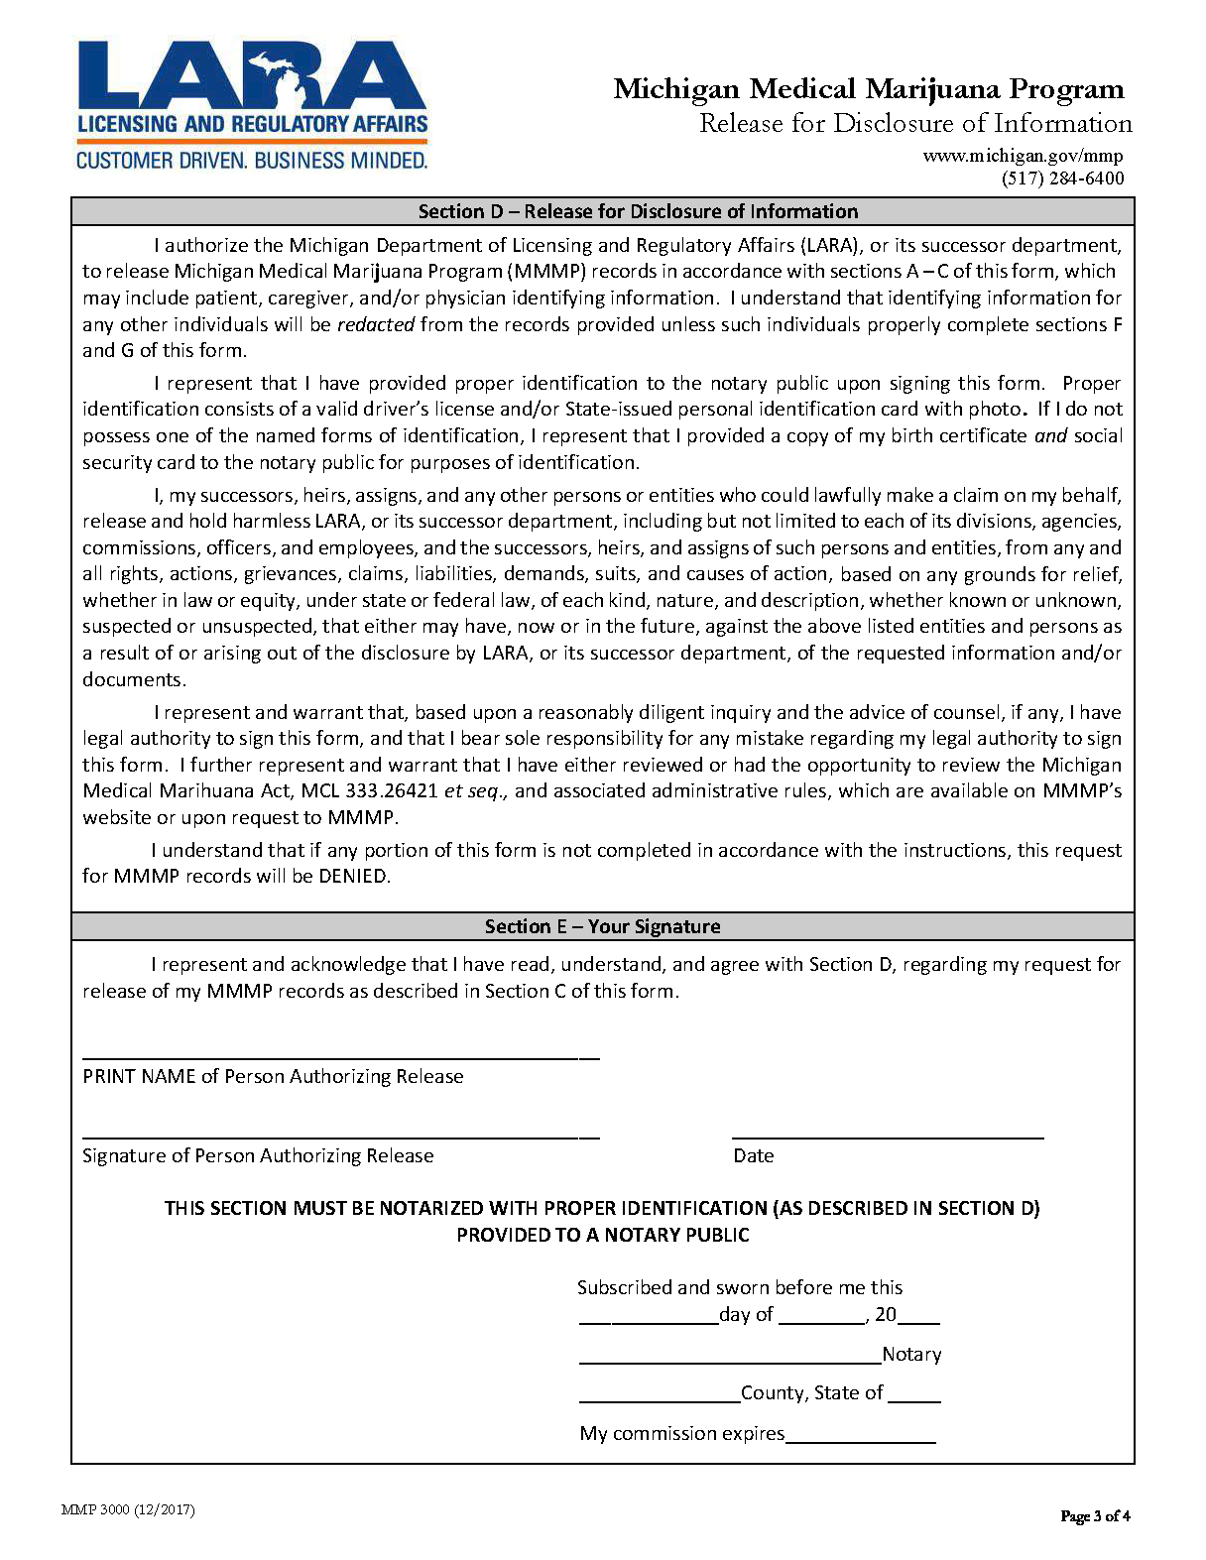
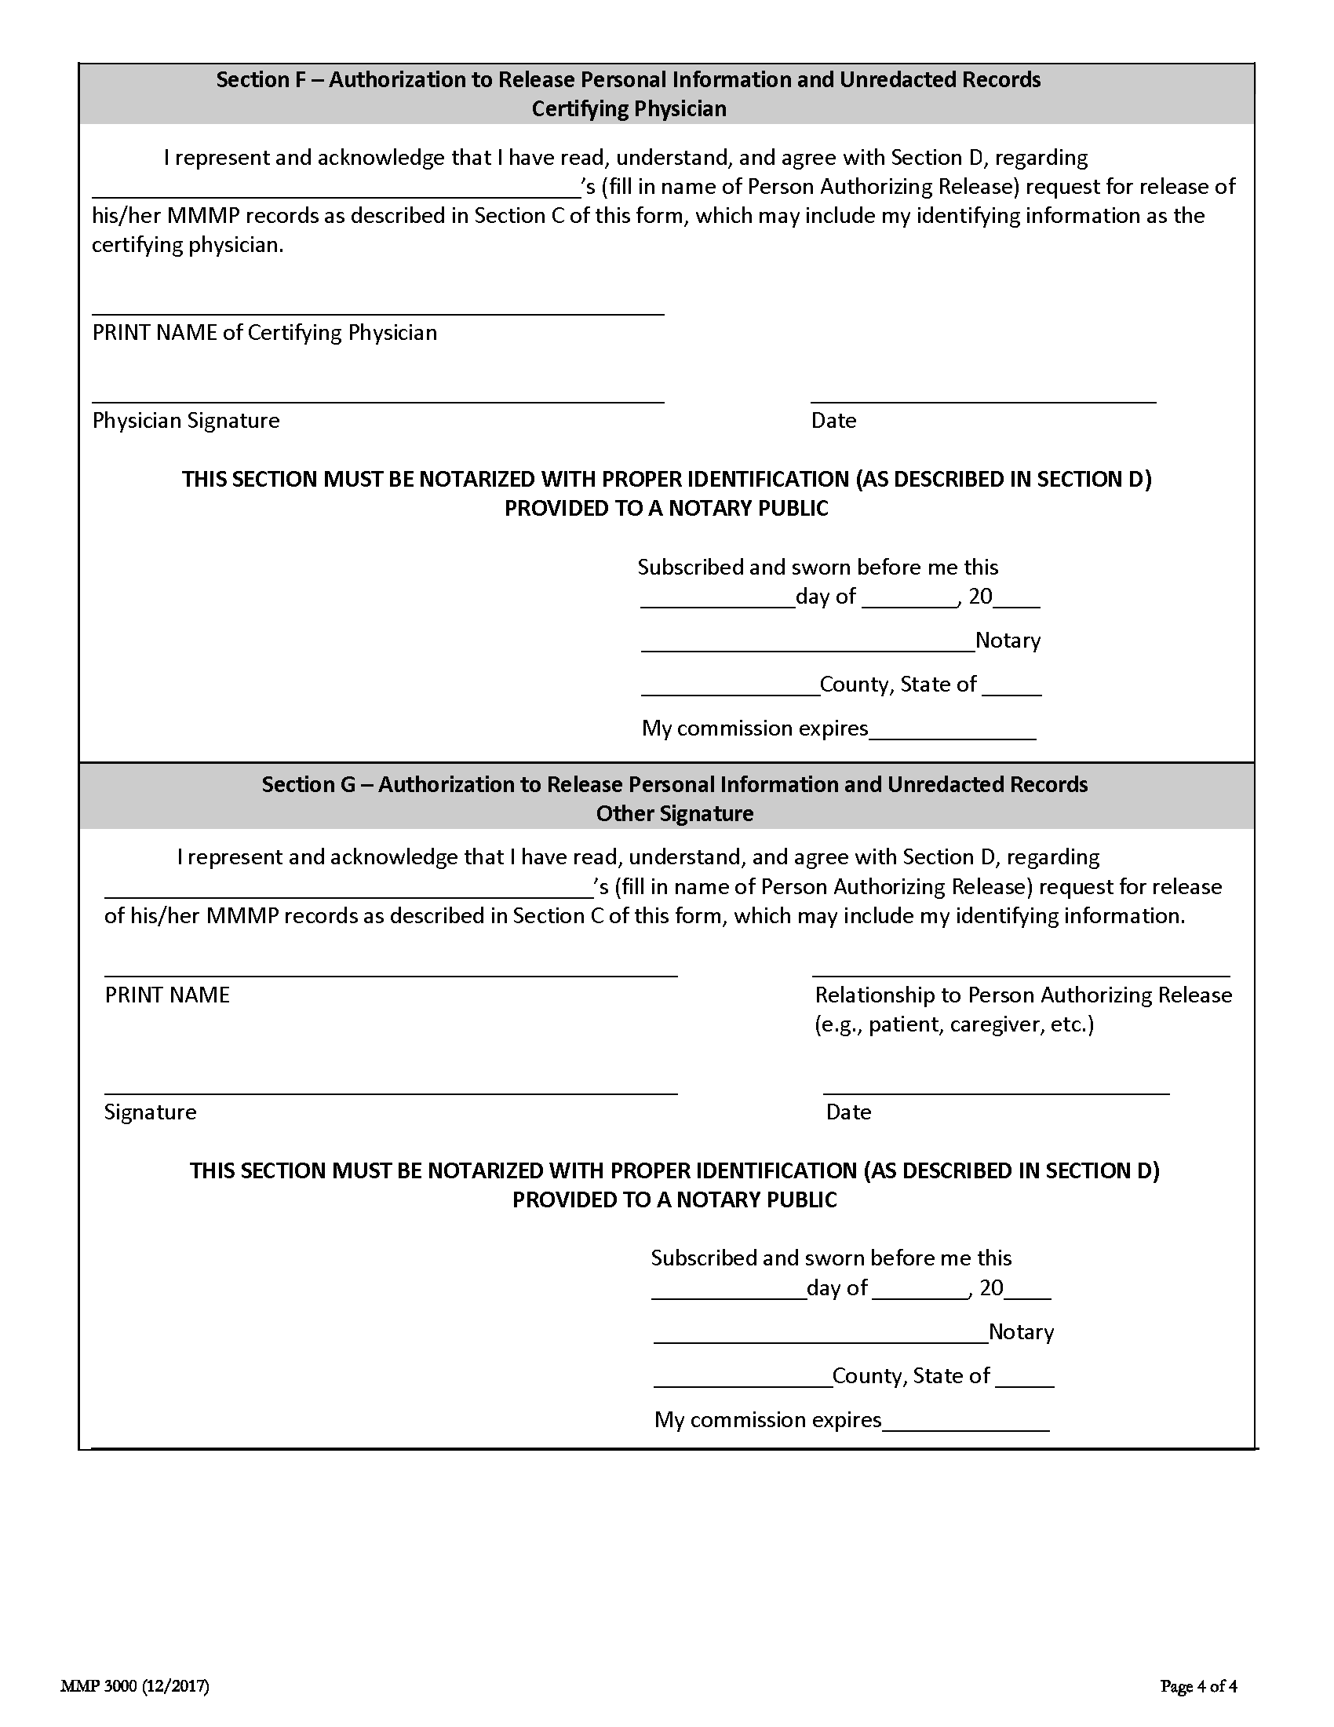
Batman

